Customer Segmentation using K-Means Clustering

Dataset:
import kagglehub

# Download latest version
path = kagglehub.dataset_download("hosseinbadrnezhad/mall-customer-segmentation-dataset")

print ("Path to dataset files:", path)

Modules
Module 1: Data Collection
Load customer dataset.
import pandas as pd
import numpy as np
import matplotlib.pyplot as plt
from sklearn.cluster import KMeans

df=pd.read_csv("/kaggle/input/mall-customer-segmentation-dataset/store_customers.csv")
print (df.head(10))

Module 2: Data Preprocessing
Select features
Normalize data
df=df.dropna()
df=df.fillna(0)

x=df[['Annual Income (k$)','Spending Score (1-100)']].values
elboww = []
for i in range(1, 11):
kmeans = KMeans(n_clusters=i, random_state=42)
kmeans.fit(x)
elboww.append(kmeans.inertia_)

Module 3: Find Optimal Clusters
Use Elbow Method
plt.plot(range(1, 11), elboww)
plt.title("Elbow Method")
plt.xlabel("Number of clusters")
plt.ylabel("Elbow")
plt.show()

Module 4: Train K-Means Model Cluster customers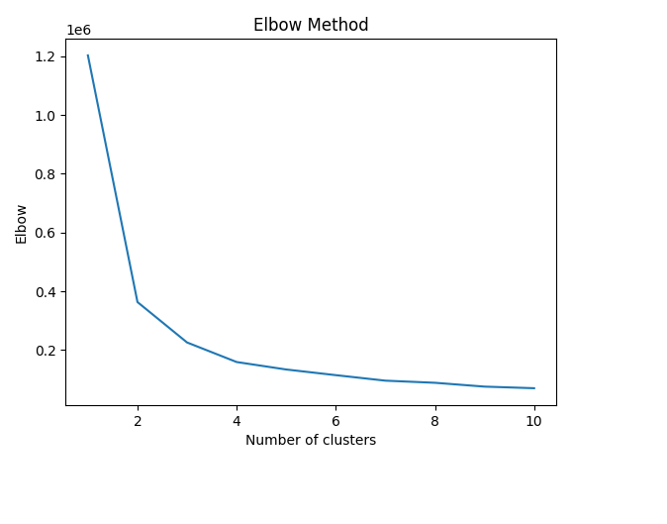

Module 4: Train K-Means Model
Cluster customers
model = KMeans(n_clusters=5, random_state=42)
labels = model.fit_predict(x)

Module 5: Visualization
Display clusters using graphs
plt.scatter(x[:,0], x[:,1], c=labels, cmap='rainbow')
plt.xlabel("Annual Income")
plt.ylabel("Spending Score")
plt.title("Customer Segmentation using K-Means")
plt.show()
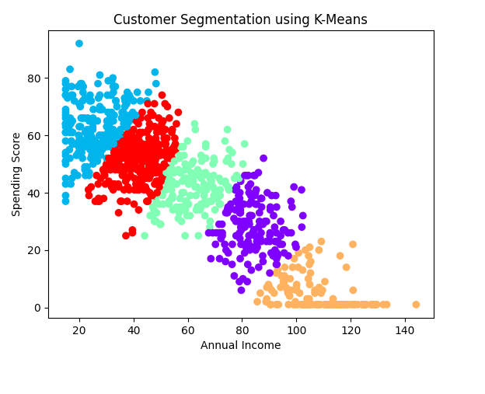

Viva Questions
What is clustering?
Clustering is an unsupervised machine learning technique that groups data points into clusters based on similarity, helping reveal hidden patterns in complex datasets without requiring predefined labels. It’s widely used in fields like marketing, healthcare, image processing, and social network analysis.
Difference between supervised and unsupervised learning?
The primary difference between supervised and unsupervised learning is the type of data used for training. Supervised learning uses labeled data (inputs with known answers), while unsupervised learning uses unlabeled data (raw information with no predefined answers).
What is K-Means?
In the KNN algorithm k is just a number that tells the algorithm how many nearby points or neighbors to look at when it makes a decision.
Example: Imagine you're deciding which fruit it is based on its shape and size. You compare it to fruits you already know.
*If k = 3, the algorithm looks at the 3 closest fruits to the new one.
*If 2 of those 3 fruits are apples and 1 is a banana, the algorithm says the new fruit is an apple because most of its neighbors are apples.
What is centroid?
In machine learning, a centroid is the central point of a cluster, typically defined as the mean of all the data points belonging to that cluster. It’s a mathematical representation of the "center" of the group and plays a crucial role in clustering algorithms.
Explain Elbow Method
In Elbow Method we draw a graph showing the error rate or accuracy for different k values. As k increases the error usually drops at first. But after a certain point error stops decreasing quickly. The point where the curve changes direction and looks like an "elbow" is usually the best choice for k.

Colab Link:
https://colab.research.google.com/drive/1tbo5DWs-KRYXAFHvU-0F5WnnKlRPBFeU?usp=sharing

